1. Logged into AWS console <https://779557092156.signin.aws.amazon.com/console>
2. Click on EC2 on All services

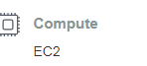

1. Click on launch instances and select Launch Instace

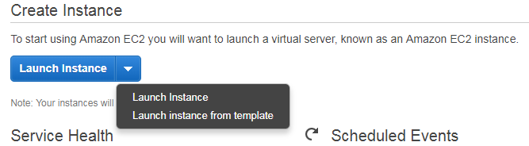

1. Select Amazon Machine Image, ex: Select Red Hat Linux



1. Choose instace type

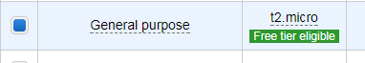

1. Review and launch
2. Create a new key pair and download key Pair

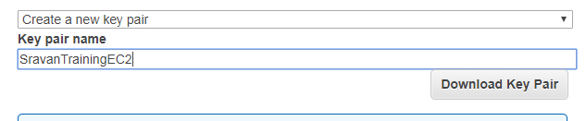

1. SravanTrainingEC2 has.pem been created.
2. Convert \*.pem to \*.ppk using putty gen
3. Open Putty gen and click on Load

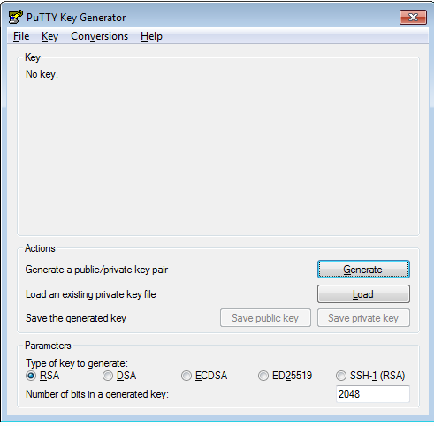

1. Click on Load and select ppm file then click OK.

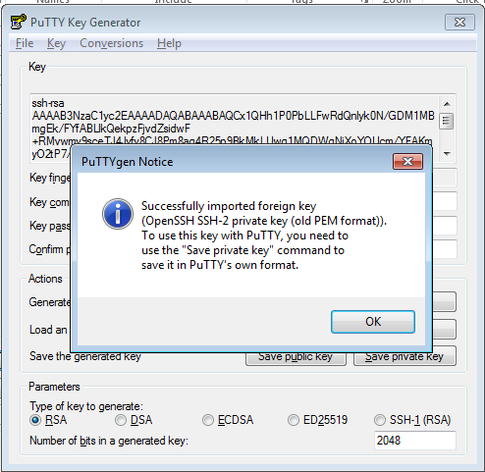

1. Click OK and click on save private key.

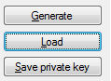Sav

1. Save file name with SravanTrainingEC2.ppk
2. Select existing keypair SravanTraining and Launch.
3. Select Instance and choose Public IP

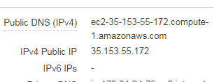

1. Open Putty and connect with Public Ip

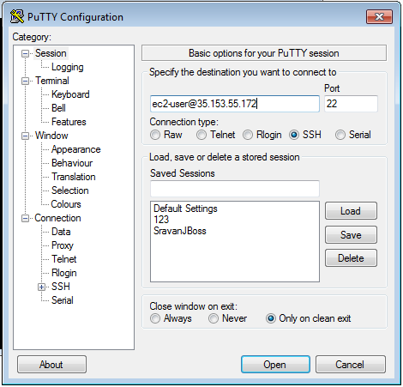

1. Expand SSH from Left side tab and click on Auth then select PPK file

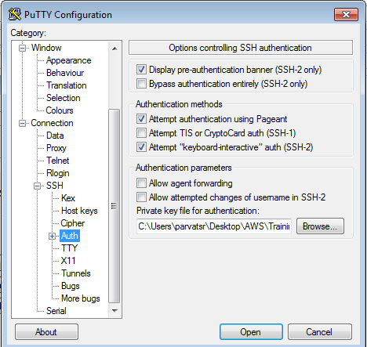

1. Connected Linux Server

